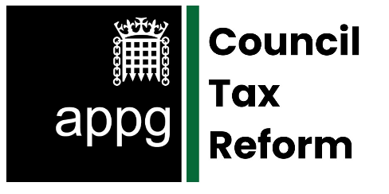

**Meeting Agenda**  
**Date:** Tuesday, 15th July 2025  
**Time:** 09:30  
**Location:** Room C, 1 Parliament Street

**Welcome and Opening Remarks**  
 *Jonathan Brash MP, Chair of the APPG*

**Council Tax Debt and Recovery – National Overview**  
 *Introduction to the issue and current trends in arrears and*  *enforcement.*

**Guest Speakers**

**John Pears**, Lowell Financial  
 *Insights from the debt recovery sector on the impact and*  *challenges of Council Tax collection.*

**Dr Peter Kenway,** NPI  
 *Research findings on the consequences of Council Tax*  *debt and local variations.*

**Tracey Herrington,** *Thrive Teesside*

*Lived experience of people in debt and living in poverty*

**Constituency-Level Insights**  
 *Distribution of briefing information and discussion of relevant trends.*

**Group Discussion**  
 *Open floor for MPs, peers and advisers to raise local concerns and*  *policy ideas.*

**Next Steps**  
 *Future APPG sessions and ongoing engagement with MHCLG.*