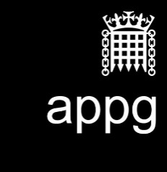

**All-Party Parliamentary Media Group**

**Annual General Meeting: 15th October 2019, Dining Room A, Palace of Westminster**

**Attendees:** Lord Gordon of Strathblane [Chair]; John Grogan MP; Baroness Howe of Idlicote; Lord Holmes of Richmond; Lord Storey; Roger Gale MP; Earl of Glasgow; Lord Young of Norwood Green; Hugh Gaffney MP; Chris Matheson MP.

Laura McCarthy (Assistant to the Clerk)

Chris Whitehouse (Clerk)

Anirban Roy (Arqiva)

Simon Beresford-Wylie (Arqiva)

Steve Holebrook (Arqiva)

Jane Vass (Age UK)

**Apologies:** Baroness Bonham Carter

**Agenda**

**1. Approval of annual report**

The report was unanimously approved by Members.

**2. Approval of financial statement**

The Group's financial statement 30 June 2018 – 29 June 2019 was approved by Members and signed by the Chair.

**3. Election of officers**

The Group's officers were unanimously elected and are as follows:

Rosie Cooper MP - Chair

Lord Jimmy Gordon of Strathblane - Vice-Chair

Mark Pritchard MP - Vice-Chair

John Nicholson MP - Vice-Chair

Baroness Bonham-Carter of Yarnbury - Vice-Chair

Ed Vaizey MP - Vice-Chair

Lord Foster of Bath - Vice-Chair

Lord Birt - Vice-Chair

Sir Peter Bottomley MP - Honorary Secretary

Sir Roger Gale MP - Honorary Secretary

John Grogan MP – Honorary Secretary

**4. Future activity**

There was no further activity.

**5. AOB**

There was no other business.